Objective:Job Resume

INTERNSHIP
DURATION 4 MONTHS
STARTING ON 1 MARCH 2017
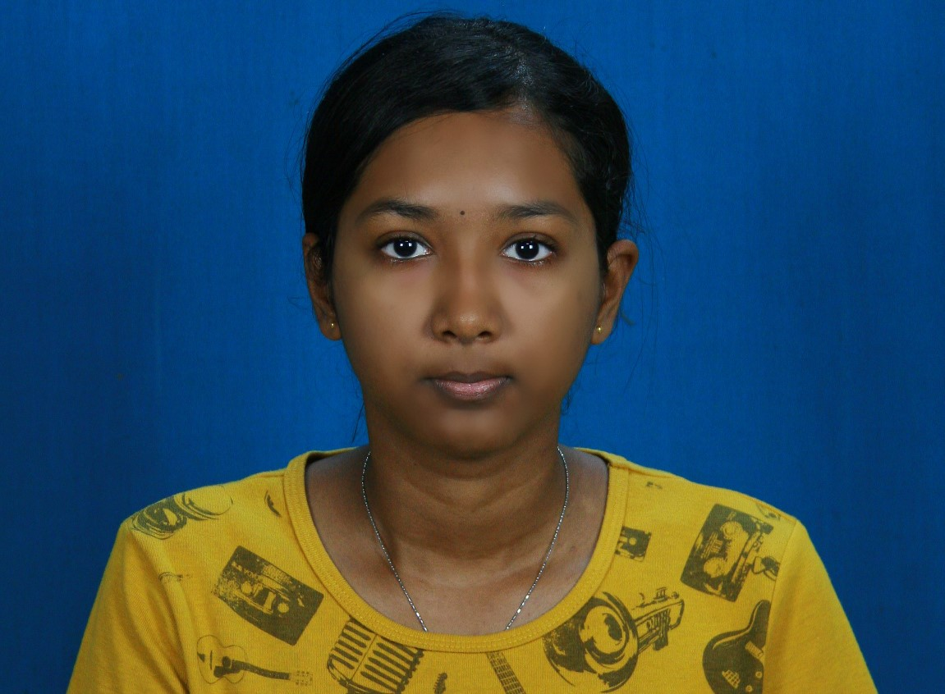

Education background

High School: SMK SERI SERDANG

Institude/University:MANAGEMENT AND SCIENCE UNIVERSITY (MSU)

Field of Study:DIPLOMA IN BUSINESS MANAGEMENT(FBMP)

Location:SHAH ALAM

COMPUTER SKILLS

- MICROSOFT WORD
- MICROSFT POWER POINT
- ANIMATION AND GRAPICS ( LOW )

WORKING EXPERIENCES

- WORKED AT AEON EQUINE PARK AS SALES PROMOTER

- TO GREET AND SERVE CUSTOMER
- PER MONTH SALARY = RM`1000 WITH COMMISEN

- WORKED AS A SALES PROMOTER AT THE LUGGAGE DEPARTMENT FOR 1 MONTH AT JUSCO EQUINE PARK.

- SERVE CUSTOMERS AS PREFFERED.
- PERMONTH SALARY RM1000

3) WORKED IN MCDONALD EQUINE PARK AS CREW.

- TO GREET AND SERVE CUSTOMER
- PER MONTH SALARY RM 1000-1300

4)CURRENTLY WORKED AT STARBUCKS AS BARISTA

- TO GREET AND SERVE CUSTOMER
- PER MONTH SALARY RM 1500

CURRICULAM VITAE

Name | SHERLYN A/P SELVARAJAH
Address | A-G-11,BLOK A,PANGSAPURI PUTRA IMPIAN, SEKSYEN 2 PP 39, TAMAN PINGGIRAN PUTRA, 43300 SERI KEMBANGAN SELANGOR.
Gender | FEMALE
NRIC No. | 960422-105434
Age | 21
Date of Birth | 22-04-1996
Nationality | MALAYSIAN
Race / Religion | INDIAN/KRISTIAN
Health | NOT SUFFERING WITH ANY CRONIC DISEASES
Hobbies | SWIMMING & READING BOOKS
E-mail address | sherlynshasha@gmail.com
Contact No. | 0172420474
Language  (Spoken) | ENGLISH, MALAY & TAMIL
Language  (Written)  Position | ENGLISH & MALAY  Any Position
Expected  Salary | -
Preferred location | -
Strengths | Reliable in getting tasks done efficiently;  A fast leaner who is able to work independently or in team;  Self disciplined, adaptable to changing environment, conscientious and diligent
Career Objective | Aspire to be an asset to the organization that I am part of to display and  exemplify the professionalism that benefits the position. I am looking for a  position that will build upon my skills and experience in management  and that would allow me to scope for upward movement.

PREFERENCE

1. WILING TO TRAVEL: MAYBE

2. WILING TO SHIFT: NO

3. POSSES OWN TRANSPORT:YES

THE GREATEST PLEASURE IN LIFE IS DOING WHAT PEOPLE SAY YOU CANNOT DO’.

Dear Sir / Madam,

Re: Application for

Kindly spare your valuable time to read my resume herewith attached.

I am a dynamic, motivated and an individual with good inter-personal skills and ethics to work as a team. The exposure in discovering the power of teamwork, hard work and a positive attitude will ensure that I can receive training in order to prepare myself with the capabilities to reach my potential as an outstanding.

I will work hard and use every available opportunity during working to learn as much as possible in order to enhance my knowledge and practical experience with opportunity for career advancement and professional growth.

Working for a firm, which is dedicated to sustaining a prestigious and top-flight practice, will expose various opportunities for me to learn and my general intention is to ensure that I can receive training in and exposure to as much area of practices as possible.

Thank you for your time in reading this letter together with my resume. I hope to hear from you soon.

Yours Sincerely,

SHERLYN A/P SELVARAJAH

